Community Event Planning and Management System

Samita Tamang
Department of Computer Science, Monroe University
CS700-151HY: Special Projects in Computer Science I
Prof. Oluwole Omole-Ohonsi
June 14, 2025

DFDs for Community Event Planning and Management System
Context Level DFD
1. Main System
Process:
1.0 Community Event Planning and Management System

2. External Entities
Entity | Role Description
Event Organizer | Creates, edits, and manages events
Community Member | Registers for events, provides feedback
Volunteer | Signs up for event tasks, views assigned duties
Admin | Manages users, oversees event approval and configurations
Sponsor | Contributes funds or resources, receives impact reports and acknowledgements

3. Data Flows with Directions
Entity | Data Flow to System (→) | Data Flow from System (←)
Event Organizer | Event Details*, Event Edits* | Event Confirmation*, Status Notifications*
Community Member | Registration Info*, Feedback* | Event Listings*, Registration Confirmation*, Alerts*
Volunteer | Availability*, Task Requests* | Task Schedule*, Assignment Details*
Admin | System Settings*, User Actions*, Event Approval* | Logs*, Admin Notifications*, Reports*
Sponsor | Sponsorship Info*, Funding Details* | Sponsorship Acknowledgement*, Event Reports*

4. Data Flow Attributes Table
Data Flow | Attributes
Event Details* | Event Name, Description, Location, Date, Time, Requirements
Event Edits* | Updated Event Name, New Date, Time Change, Description Changes
Event Confirmation* | Event ID, Confirmation Status, Organizer Message
Status Notifications* | Event ID, Status Message, Timestamp
Registration Info* | Full Name, Email, Selected Event ID
Feedback* | Event ID, User ID, Rating, Comments
Event Listings* | Event Titles, Dates, Locations
Registration Confirmation* | User ID, Event ID, Confirmation Code
Alerts* | Message, Date, User ID
Availability* | Volunteer ID, Available Dates, Times
Task Requests* | Task Type, Preferred Time, Volunteer ID
Task Schedule* | Assigned Task, Date, Time, Volunteer ID
Assignment Details* | Task Name, Description, Deadline
System Settings* | Config Params, Thresholds, Limits
User Actions* | User Role, Action Type, Timestamp
Event Approval* | Event ID, Approver ID, Approval Status
Logs* | Action, Actor, Timestamp, Outcome
Admin Notifications* | Type, Message, Target Role/User
Reports* | Event Metrics, User Stats, Feedback Summary
Sponsorship Info* | Sponsor Name, Resource/Item Sponsored, Quantity
Funding Details* | Amount, Payment Method, Date
Sponsorship Acknowledgement* | Sponsor ID, Acknowledgment Message, Event Title
Event Reports* | Summary of Sponsored Event, Outcome, Audience

Context Level DFD
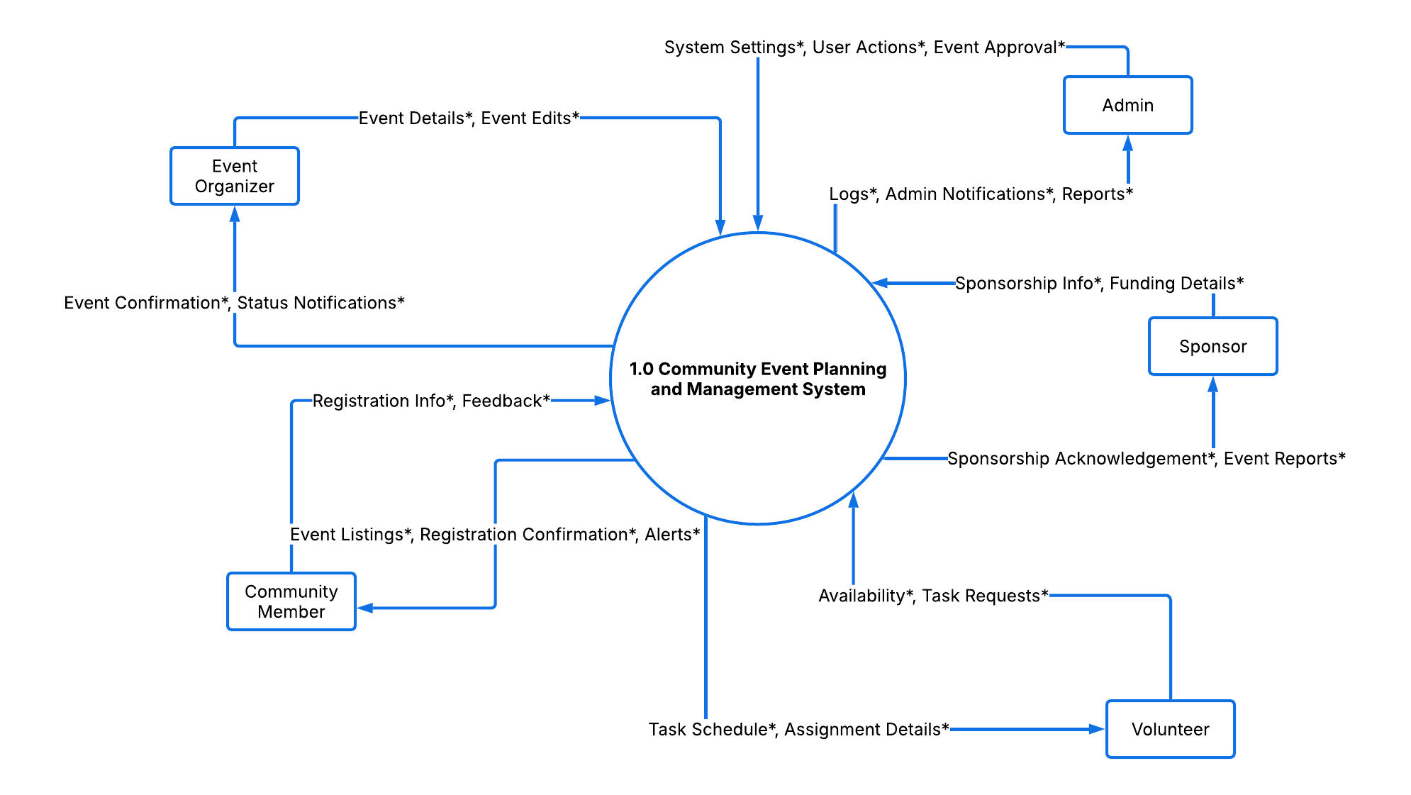
Level 0 DFD
1. Main Subprocesses
ID | Process Name
1.0 | Manage Events
2.0 | Handle Registrations and Feedback
3.0 | Manage Volunteers
4.0 | Manage Sponsorships
5.0 | Administer System and Generate Reports
2. Data Stores
Data Store ID | Name | Description
D1 | Event Data | All details of created and edited events
D2 | User and Registration Data | Community members, their registrations, and feedback
D3 | Volunteer Records | Volunteer profiles, availability, and assignments
D4 | Sponsorship Records | Details of sponsors and funding
D5 | System Logs and Reports | Logs, notifications, reports, admin actions
3. Data Flow Attribute Table
Data Flow | Attributes
Event Details* | Title, Description, Location, Date, Time
Event Updates* | Updated Details, Event ID
Event Confirmation* | Event ID, Status Message
Status Updates* | Status Message, Timestamp
Registration Info* | Name, Email, Event ID
Feedback* | Event ID, Rating, Comments
Registration Confirmation* | Confirmation Code, Event Info
Notifications* | Message, Type, Date
New User Info* | Name, Email, Password
Event Feedback* | User ID, Event ID, Comment
Availability* | Volunteer ID, Dates, Times
Task Requests* | Volunteer ID, Task Preference
Assigned Tasks* | Task Name, Location, Time
Schedule* | Date, Task, Volunteer ID
Volunteer Profiles* | Name, Contact Info, Skills
Assignments* | Task ID, Volunteer ID, Deadline
Sponsorship Info* | Sponsor Name, Resource Type
Funding Details* | Amount, Method, Date
Sponsorship Acknowledgment* | Message, Sponsor ID
Reports* | Summary, Feedback Stats, Metrics
Config Data* | System Limits, Roles
User Management* | User ID, Role, Status
Event Approvals* | Event ID, Admin ID, Status
Logs* | Activity, Actor, Timestamp
Admin Logs* | Admin Action, Outcome
System Reports* | Event Summary, Volunteer Performance
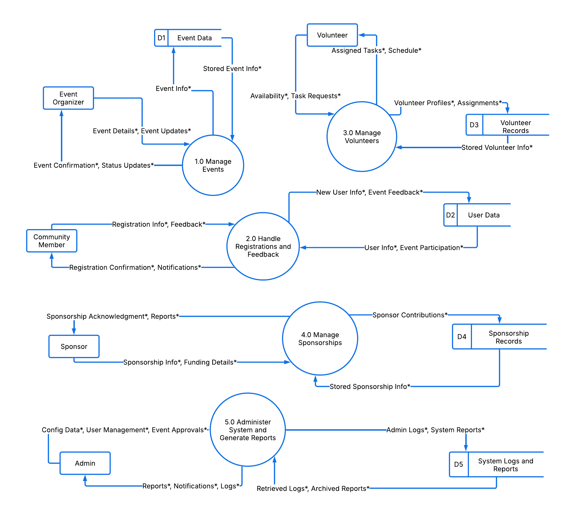

Level 1 DFDs
Process 1.0: Manage Events
Subprocesses:
- Create Event
- Edit Event Details
- Approve Event (Admin)
- Cancel or Postpone Event
Process 2.0: Handle Registrations and Participation
Subprocesses:
- 2.1 User Registration for Event
- 2.2 Confirm Attendance
- 2.3 Notify Participant
Process 3.0: Manage Volunteers
Subprocesses:
- 3.1 Volunteer Sign-Up
- 3.2 Assign Tasks
- 3.3 Update Availability
Process 4.0: Manage Users & Admin Functions
Subprocesses:
- 4.1 Create/Edit User Account
- 4.2 Assign Roles
- 4.3 System Logs and Notifications
Process 5.0: Handle Sponsorship and Reports
Subprocesses:
- 5.1 Receive Sponsorship Info
- 5.2 Generate Sponsorship Reports
- 5.3 Notify Sponsors

Level 1 DFDs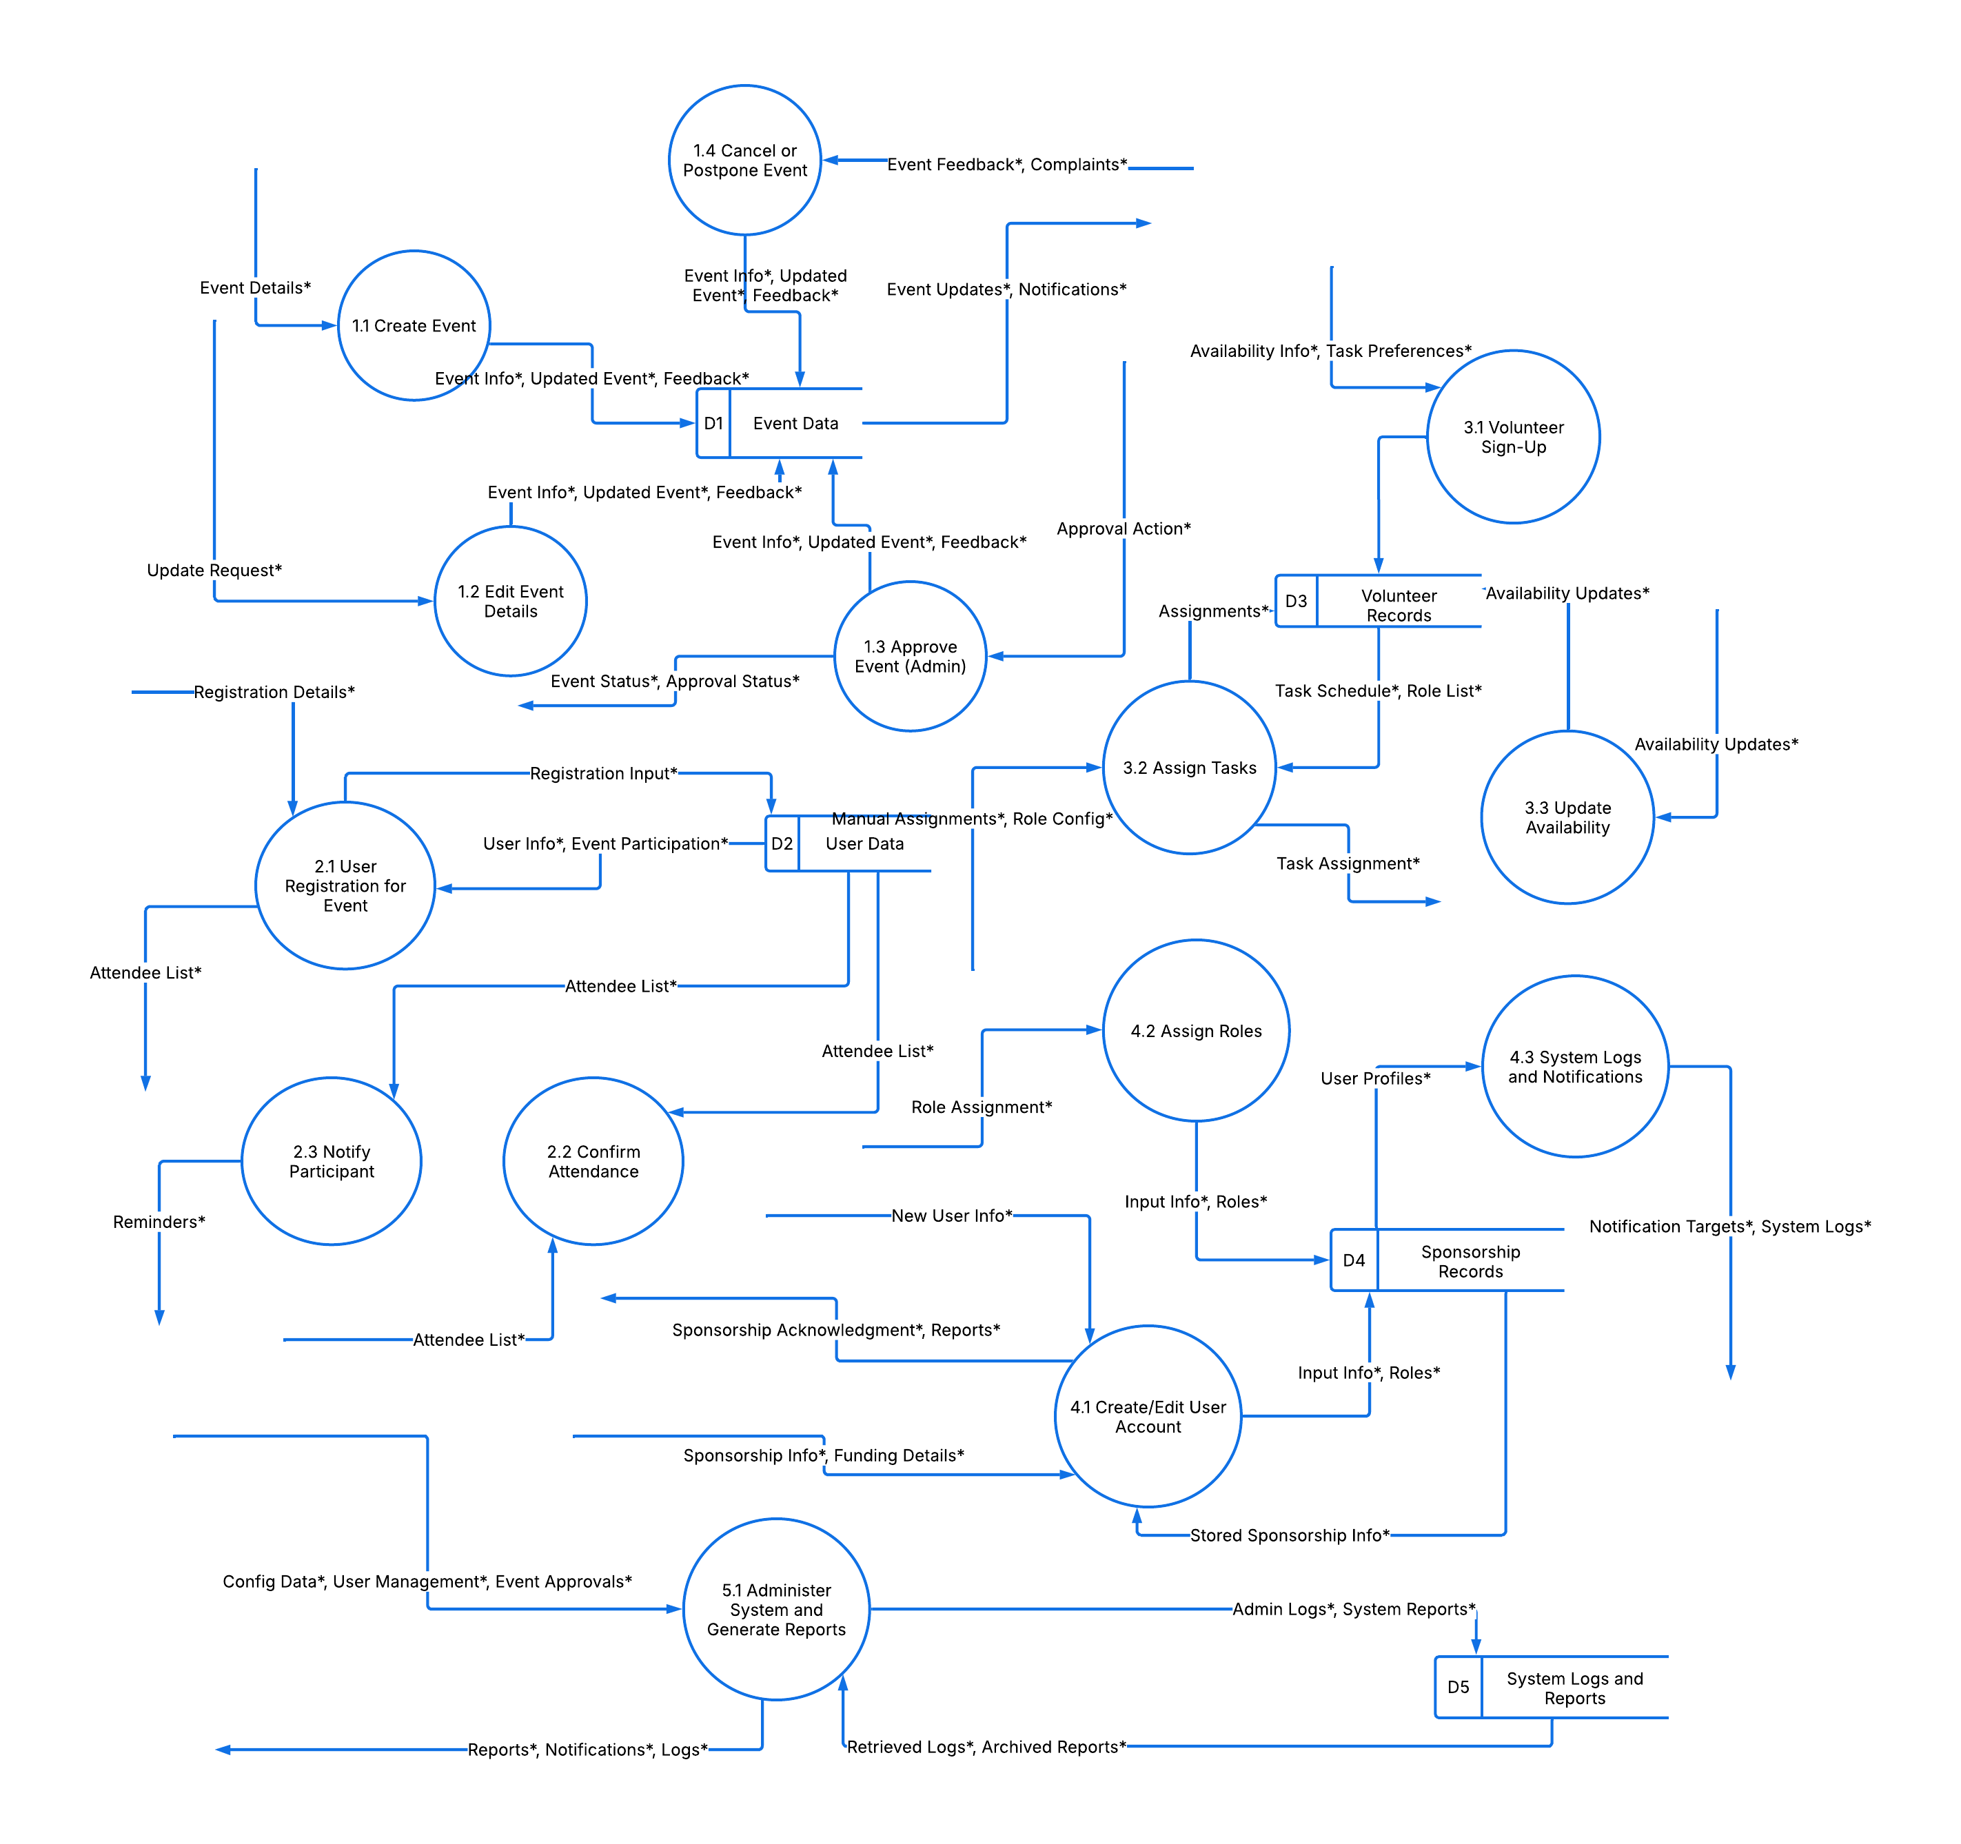

USER STORIES – Community Event Planning and Management System
User stories describe the functionality from the end-user perspective.
Event Organizer
- As an Event Organizer, I want to create a new event, so that community members can register and participate.
- As an Event Organizer, I want to edit event details, so that I can update any changes in schedule or information.
- As an Event Organizer, I want to view feedback from participants, so that I can improve future events.
- As an Event Organizer, I want to see a list of registered attendees, so that I can plan resources accordingly.

Community Member/User
- As a Community Member, I want to browse upcoming events, so that I can choose which ones to attend.
- As a Community Member, I want to register for an event, so that I can participate officially.
- As a Community Member, I want to receive notifications about the events I registered for, so that I don’t miss important updates.
- As a Community Member, I want to give feedback after attending an event, so that my opinion can help improve future events.
- As a Community Member, I want to cancel my registration, so that I don’t occupy a slot I won’t use.

Volunteer
- As a Volunteer, I want to sign up for volunteer tasks, so that I can help during events.
- As a Volunteer, I want to view my assigned tasks and schedules, so that I know what is expected of me.
- As a Volunteer, I want to update my availability, so that organizers can assign me tasks accordingly.
- As a Volunteer, I want to receive reminders about my volunteer tasks, so that I don't miss my responsibilities.

Admin
- As an Admin, I want to approve or reject events submitted by organizers, so that only valid events appear on the platform.
- As an Admin, I want to manage user accounts, so that I can block or edit user information as needed.
- As an Admin, I want to assign roles (e.g., volunteer, organizer), so that users have correct access rights.
- As an Admin, I want to view logs and reports, so that I can monitor system activities.
- As an Admin, I want to configure system settings, so that I can manage the platform easily.

Sponsor
- As a Sponsor, I want to submit sponsorship offers, so that I can support community events.
- As a Sponsor, I want to specify my sponsorship preferences, so that my contributions match my brand goals.
- As a Sponsor, I want to receive acknowledgment after sponsoring, so that I gain recognition.
- As a Sponsor, I want to receive reports on how my sponsorship was used, so that I can track impact.

